Lecture#9 Check Box and Radio Button
Objectives
- Check Box
- Check Box Tile
- Radio Button
- Radio Button Tile

Check Box:
A checkbox in Flutter is a material design widget that allows the user to select a binary option or multiple options from a set. The widget is often used to present a set of options to the user and allow them to choose one or multiple options.
Here's an example of how you can implement a checkbox in Flutter:
Constructor:
const Checkbox(
{Key key,
@required bool value,
bool tristate: false,
@required ValueChanged<bool> onChanged,
MouseCursor mouseCursor,
Color activeColor,
Color checkColor,
Color focusColor,
Color hoverColor,
MaterialTapTargetSize materialTapTargetSize,
VisualDensity visualDensity,
FocusNode focusNode,
bool autofocus: false}
)
Code:
import 'package:flutter/material.dart';

void main() => runApp(MyApp());

class MyApp extends StatefulWidget {
@override
_MyAppState createState() => _MyAppState();
}

class _MyAppState extends State<MyApp> {
bool _isChecked = false;

void _onChanged(bool? value) {
setState(() {
_isChecked = value!;
});
}

@override
Widget build(BuildContext context) {
return MaterialApp(
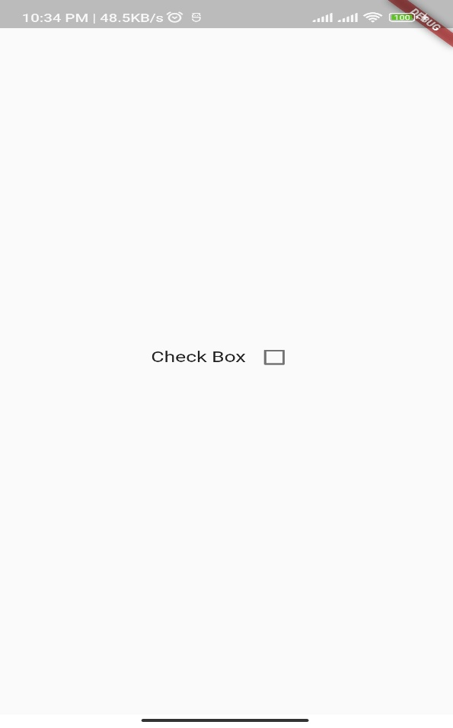
home: Scaffold(
body: Center(
child: Row(
mainAxisAlignment: MainAxisAlignment.center,
children: [
const Text("Check Box"),
Checkbox(
value: _isChecked,
onChanged: _onChanged,
),
],
),
),
),
);
}
}

In this example, the checkbox is created using the Checkbox widget. The value property is used to set the current state of the checkbox (checked or unchecked) and the onChanged property is used to listen for changes in the checkbox state.
The _isChecked variable is used to keep track of the checkbox state, and the _onChanged method is used to update the state of the checkbox whenever it changes.

Check Box List Tile:

A CheckboxListTile is a widget in Flutter that combines a checkbox with a list tile. The list tile is a standard material design component that contains information such as a title, subtitle, and leading/trailing widgets. By combining the checkbox and the list tile, the CheckboxListTile widget provides a way to present the user with a set of options in a compact and intuitive way.
Here's an example of how you can implement a CheckboxListTile in Flutter:
import 'package:flutter/material.dart';
void main() => runApp(MyApp());
class MyApp extends StatefulWidget {
@override
_MyAppState createState() => _MyAppState();
}

class _MyAppState extends State<MyApp> {
bool _isChecked = false;
void _onChanged(bool? value) {
setState(() {
_isChecked = value!;
});
}
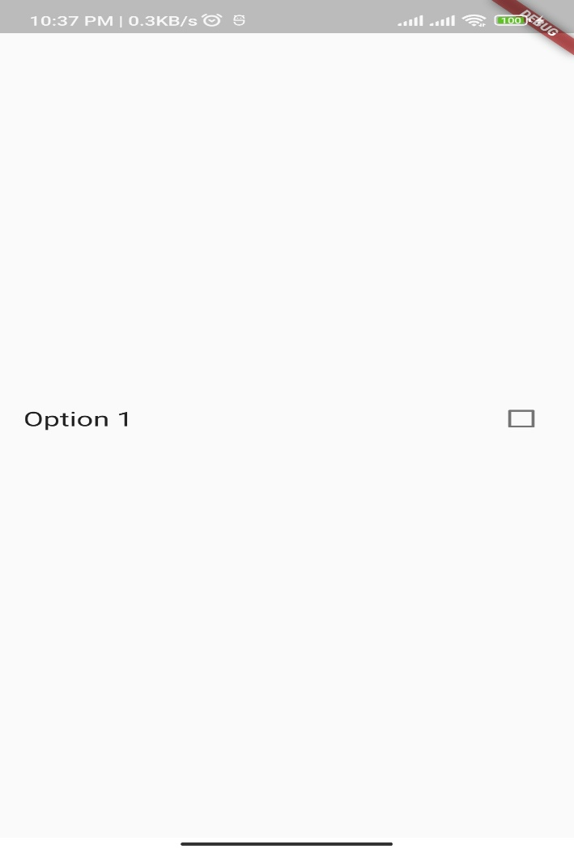
@override
Widget build(BuildContext context) {
return MaterialApp(
home: Scaffold(
body: Center(
child: CheckboxListTile(
title: Text('Option 1'),
value: _isChecked,
onChanged: _onChanged,
controlAffinity: ListTileControlAffinity.trailing,
),
),
),
);
}
}

In this example, the CheckboxListTile is created using the CheckboxListTile widget. The title property is used to set the title of the list tile, the value property is used to set the current state of the checkbox (checked or unchecked), and the onChanged property is used to listen for changes in the checkbox state.
The controlAffinity property is used to specify the placement of the checkbox with respect to the title and subtitle. In this example, the ListTileControlAffinity.leading value is used, which means that the checkbox is placed to the left of the title.
The _isChecked variable is used to keep track of the checkbox state, and the _onChanged method is used to update the state of the checkbox whenever it changes.

Radio Button:
A radio button in Flutter is a material design widget that allows the user to select a single option from a set of options. Unlike checkboxes, radio buttons are exclusive, meaning that only one option can be selected at a time. Radio buttons are often used when the user needs to choose one option from a list of options, and it's important that only one option is selected.
Here's an example of how you can implement a radio button in Flutter:
import 'package:flutter/material.dart';
void main() => runApp(MyApp());
class MyApp extends StatefulWidget {
@override
_MyAppState createState() => _MyAppState();
}
class _MyAppState extends State<MyApp> {
int _selectedValue = 0;
void _onChanged(int? value) {
setState(() {
_selectedValue = value!;
});
}
@override
Widget build(BuildContext context) {
return MaterialApp(
home: Scaffold(
body: Center(
child: Column(
mainAxisAlignment: MainAxisAlignment.center,
children: [
Row(
children: [
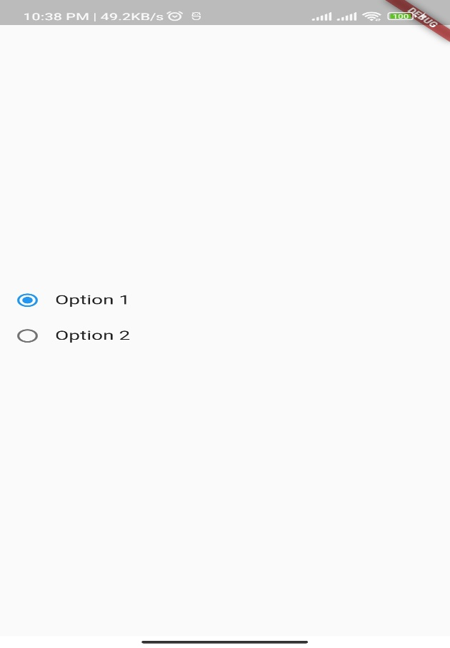
Radio(
value: 0,
groupValue: _selectedValue,
onChanged: _onChanged,
),
Text('Option 1'),
],
),
Row(
children: [
Radio(
value: 1,
groupValue: _selectedValue,
onChanged: _onChanged,
),
Text('Option 2'),
],
),
],
),
),
),
);
}
}

In this example, the radio buttons are created using the Radio widget. The value property is used to set the value of the radio button, the groupValue property is used to specify the current selected value from the set of options, and the onChanged property is used to listen for changes in the selected value.
The _selectedValue variable is used to keep track of the currently selected value, and the _onChanged method is used to update the selected value whenever it changes.
Note that in this example, multiple radio buttons are used to form a group of options. The groupValue property is used to specify the current selected value from the group of options, and the value property is used to specify the value of each individual radio button.

Radio List Tile:
The RadioListTile is a widget in Flutter that combines a radio button with a list tile. The list tile is a standard material design component that contains information such as a title, subtitle, and leading/trailing widgets. By combining the radio button and the list tile, the RadioListTile widget provides a way to present the user with a set of options in a compact and intuitive way.
Here's an example of how you can implement a RadioListTile in Flutter:
import 'package:flutter/material.dart';

void main() => runApp(MyApp());

class MyApp extends StatefulWidget {
@override
_MyAppState createState() => _MyAppState();
}

class _MyAppState extends State<MyApp> {
int _selectedValue = 0;

void _onChanged(int? value) {
setState(() {
_selectedValue = value!;
});
}

@override
Widget build(BuildContext context) {
return MaterialApp(
home: Scaffold(
body: Center(
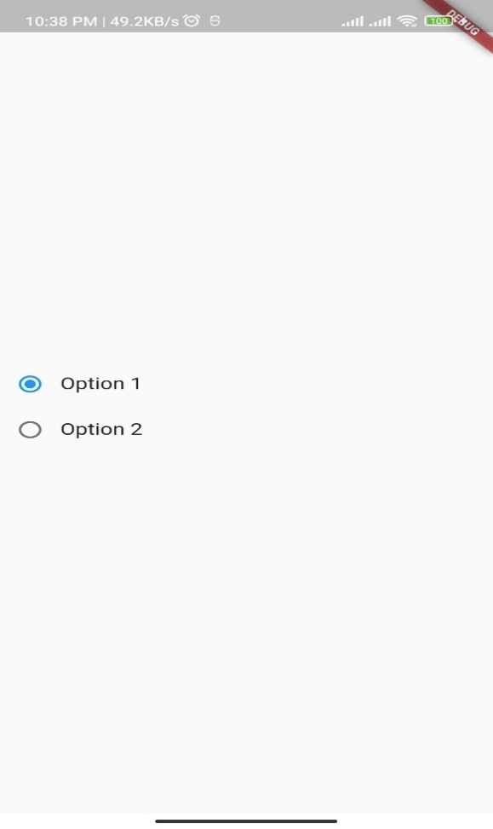
child: Column(
mainAxisAlignment: MainAxisAlignment.center,
children: [
RadioListTile(
value: 0,
groupValue: _selectedValue,
onChanged: _onChanged,
title: Text('Option 1'),
),
RadioListTile(
value: 1,
groupValue: _selectedValue,
onChanged: _onChanged,
title: Text('Option 2'),
),
],
),
),
),
);
}
}

In this example, the RadioListTile is created using the RadioListTile widget. The value property is used to set the value of the radio button, the groupValue property is used to specify the current selected value from the set of options, and the onChanged property is used to listen for changes in the selected value. The title property is used to set the title of the list tile.
The _selectedValue variable is used to keep track of the currently selected value, and the _onChanged method is used to update the selected value whenever it changes.
Note that RadioListTile works similarly to Radio, but with a more visually appealing layout. In both cases, you still need to manage the state of the selected value using variables and methods.

Lecture#10 Drop Down
Objectives
- Drop Down
- Drop Down from List
- Drop Down with images

Drop Down
A dropdown menu in Flutter is a material design widget that allows the user to select an item from a list of options. The dropdown menu is hidden until the user taps on a button or other control, at which point the menu is displayed, allowing the user to choose an option.
Here's an example of how you can implement a dropdown menu in Flutter:
import 'package:flutter/material.dart';

void main() => runApp(MyApp());

class MyApp extends StatefulWidget {
@override
_MyAppState createState() => _MyAppState();
}

class _MyAppState extends State<MyApp> {
String _selectedValue =
'Option 1'; // this value must be null or from Drop Down Menu List
@override
Widget build(BuildContext context) {
return MaterialApp(
home: Scaffold(
body: Center(
child: Column(
mainAxisAlignment: MainAxisAlignment.center,
children: [
DropdownButton(
value: _selectedValue,
items: [
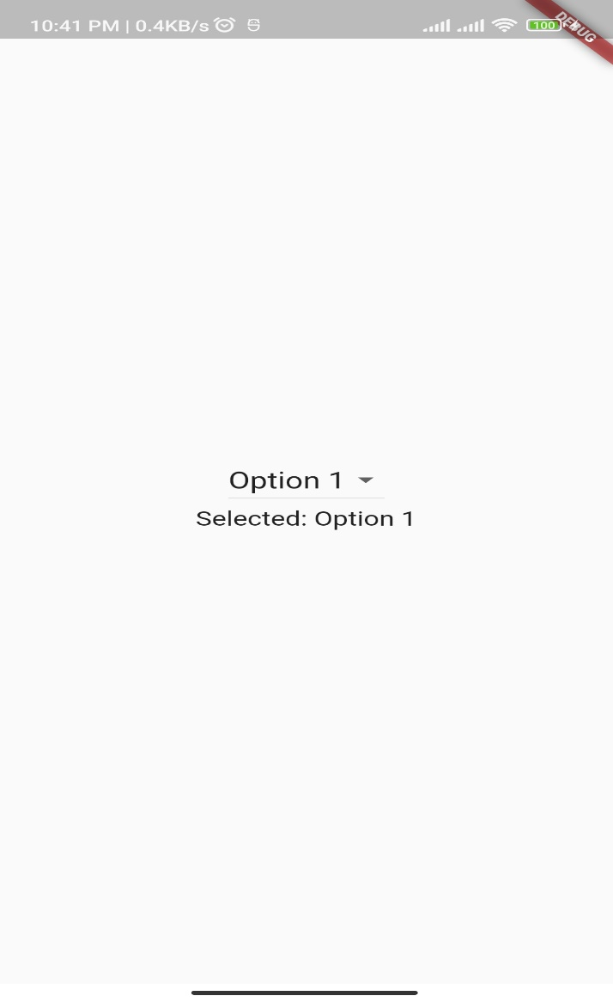
DropdownMenuItem(
child: Text('Option 1'),
value: 'Option 1',
),
DropdownMenuItem(
child: Text('Option 2'),
value: 'Option 2',
),
DropdownMenuItem(
child: Text('Option 3'),
value: 'Option 3',
),
],
onChanged: (value) {
setState(() {
_selectedValue = value!;
});
},
),
Text('Selected: $_selectedValue'),
],
),
),
),
);
}
}

In this example, the dropdown menu is created using the DropdownButton widget. The value property is used to specify the currently selected value, and the items property is used to specify the list of options that the user can choose from. The onChanged property is used to listen for changes in the selected value.
The _selectedValue variable is used to keep track of the currently selected value, and the setState method is used to update the selected value whenever it changes. The selected value is displayed below the dropdown menu for demonstration purposes.
Note that the dropdown menu can be customized in many ways, such as by changing the style, color, and size of the button, by adding a custom icon, or by using a custom widget as the dropdown menu item.

Drop Down from a List
import 'package:flutter/material.dart';

void main() => runApp(MyApp());

class MyApp extends StatefulWidget {
@override
_MyAppState createState() => _MyAppState();
}

class _MyAppState extends State<MyApp> {
String _selectedOption = 'Pakistan';

final List<String> options = [
'Pakistan',
'India',
'Afghanistan',
'Bangladesh',
];

@override
Widget build(BuildContext context) {
return MaterialApp(
home: Scaffold(
body: Center(
child: Column(
mainAxisAlignment: MainAxisAlignment.center,
children: [
DropdownButton(
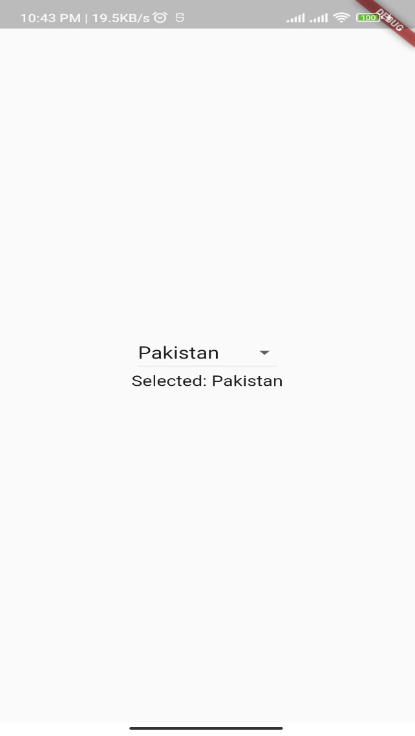
value: _selectedOption,
items: options.map((String option) {
return DropdownMenuItem(
value: option,
child: Text(option),
);
}).toList(),
onChanged: (value) {
setState(() {
_selectedOption = value!;
});
},
),
Text('Selected: $_selectedOption'),
],
),
),
),
);
}
}

In this example, the options are defined in a list called options. The DropdownButton widget is used to display the dropdown menu. The value property is used to specify the currently selected value, and the items property is used to specify the list of options that the user can choose from. The map method is used to convert the list of options into a list of DropdownMenuItem widgets. The onChanged property is used to listen for changes in the selected value.
The _selectedOption variable is used to keep track of the currently selected value, and the setState method is used to update the selected value whenever it changes. The selected value is displayed below the dropdown menu for demonstration purposes.

Drop Down with Images
Assume that there is a list of images in assets example given below shows drop down with images
import 'package:flutter/material.dart';

void main() => runApp(MyApp());

class MyApp extends StatefulWidget {
@override
_MyAppState createState() => _MyAppState();
}

class _MyAppState extends State<MyApp> {
String _selectedFlag = 'flag1.png';

final Map<String, AssetImage> flags = {
'flag1.png': AssetImage('images/flag1.png'),
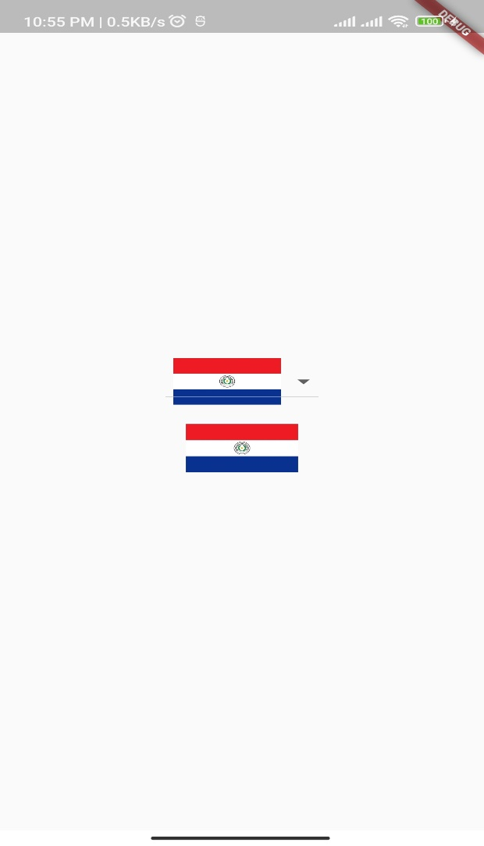
'flag2.png': AssetImage('images/flag2.png'),
'flag3.png': AssetImage('images/flag3.png'),
};

@override
Widget build(BuildContext context) {
return MaterialApp(
home: Scaffold(
body: Center(
child: Column(
mainAxisAlignment: MainAxisAlignment.center,
children: [
DropdownButton(
value: _selectedFlag,
items: flags.keys.map((String key) {
return DropdownMenuItem(
value: key,
child: Image(
image: flags[key]!,
height: 50,
width: 100,
),
);
}).toList(),
onChanged: (value) {
setState(() {
_selectedFlag = value!;
});
},
),
SizedBox(
height: 20,
),
Image(
image: flags[_selectedFlag]!,
height: 50,
width: 100,
),
],
),
),
),
);
}
}

